Technical Datasheet Input / Output Modules with Modbus RTU Protocol with RS485 Interface

The IO module communicates via Ethernet Interface. The module is designed to allow interface with other Modbus TCP/IP compatible devices. The module acts as an input/output device between the Modbus TCP/IP Network and the Gateway.
Digital IO module is sturdy, low power usage and easy to use.

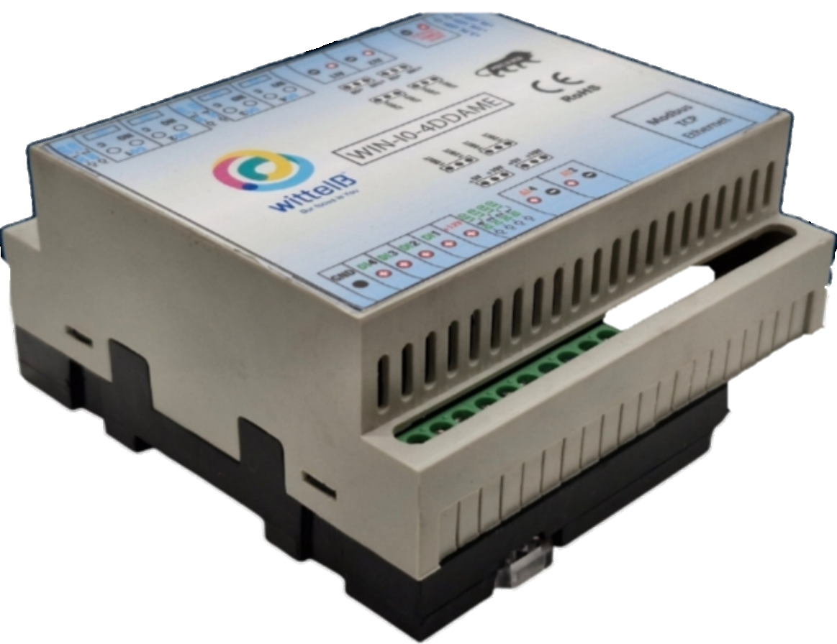
4 Port DO + 4 DI + 4 AI Module with Modbus TCP Ethernet: -

The IO modules enclosures are DIN rail Mountable. It’s a closed Enclosure with openings for connectors and LED indicators.
The design of the modules incorporates ‘resettable Fuses’ to safeguard against reverse polarity connection for Power Input.
There are LED indicators for each of the IO ports as well as for the module Power.

Specifications
General –

I/O Connectors 22 Pin 5.08 mm pitch pluggable screw Terminal Block, 2 Pin 5.08 mm pitch pluggable screw terminals.
Dimensions 110 mm L x 110 mm B x 50 mm H
Power Input Power – 12-24 V DC
Typical – 12V DC @ 120mA
Operating Temperature 0 – 60° C (32 ~ 140°F)
Storage Temperature -20 - 70° C (-4 ~ 158°F)
Storage Humidity 5 ~ 95 % RH, non – Condensing
Certifications 

DO with Relay Output –

Channels 4
Contact Form 1A, 1C
Contact Material Ag Alloy
Contact Capacity 10A @ 240VAC, 10A @ 28VDC
Coil Voltage 5 – 48 VDC
Coil Power 0.36 W
Insulation Resistance 250MΩ
Electrical Life 1 x 10^5
Mechanical Life 1 x 10^7
Operating Time 7 msec, Max 15 msec
Release Time 2 msec, Max 6 msec

DI Inputs –

Channels 4
Sense Voltage 3.3 – 30 VDC
Sense Logic Logic ‘0’ = <1 VDC, Logic ‘1’ = >3.3 VDC
Isolation Optically isolated
Response Time 2 msec, Max 6 msec

AI Inputs –

Channels 4
Input Signal 4 – 20 mA / 0 – 10VDC / NTC Type 3 (jumper selectable)
Accuracy ± 2% Full scale
Input Resolution 10 bits / 12 bits (Optional)
Isolation Optically Isolated
External Loop Voltage + 12 VDC min
AI input impedance 120Ω

Configuration Settings: -

Communication Speed 10/100 Base-T Ethernet Interface
Data Bits 8
Parity None
Stop bit 1
CRC Yes
Slave ID Configurable over Web Interface
Function code DO 0x05 and 0x0F (5 Single coil & 15 multiple coil)
DO Register Address 4,5,6,7.
Function code DI 0x02 Read discrete Input
DI Register Address 0,1,2,3.
Function Code AI 0x03 Read Holding Registers
AI Register Address 10 Bit - 2,3,4,5 / 12 Bit – 6,7,8,9.

ID | Function  Description | Register  Description | Modbus Function Code | Protocol | Data  Type
1 | DO 1 | 00001 | 0X05,0X0F | RS485 | 1 Bit Boolean
2 | DO 2 | 00002 | 0X05,0X0F | RS485 | 1 Bit Boolean
3 | DO 3 | 00003 | 0X05,0X0F | RS485 | 1 Bit Boolean
4 | DO 4 | 00004 | 0X05,0X0F | RS485 | 1 Bit Boolean
5 | DI 1(With & Without Potential) | 10005 | 0X02 | RS485 | 1 Bit Boolean
6 | DI 2(With & Without Potential) | 10006 | 0X02 | RS485 | 1 Bit Boolean
7 | DI 3(With & Without Potential) | 10007 | 0X02 | RS485 | 1 Bit Boolean
8 | DI 4(With & Without Potential) | 10008 | 0X02 | RS485 | 1 Bit Boolean
9 | AI 1 – 10 Bit | 40002 | 0X03 | RS485 | 16 Bit Unsigned int
10 | AI 2 – 10 Bit | 40003 | 0X03 | RS485 | 16 Bit Unsigned int
11 | AI 3 – 10 Bit | 40004 | 0X03 | RS485 | 16 Bit Unsigned int
12 | AI 4 – 10 Bit | 40005 | 0X03 | RS485 | 16 Bit Unsigned int
13 | AI 1 – 12 Bit | 40006 | 0x03 | RS485 | 16 Bit Unsigned int
14 | AI 2 – 12 Bit | 40007 | 0x03 | RS485 | 16 Bit Unsigned int
15 | AI 3 – 12 Bit | 40008 | 0x03 | RS485 | 16 Bit Unsigned int
16 | AI 4 – 12 Bit | 40009 | 0x03 | RS485 | 16 Bit Unsigned int

Configuration Guide – Ethernet Modbus TCP/IP IO Module:-

- Open a web browser (Google Chrome, Microsoft Edge, Firefox, etc.).
- In the browser’s address bar, type the default IP address:
192.168.0.160
- Press Enter. A message will appear saying:
“Please go to http://192.168.0.160/setup.”
- Copy this link (http://192.168.0.160/setup) and paste it into a new browser tab.
- Press Enter again to open the Setup / Configuration Page of the device.

To Reset the Device to Default Settings
- Place the jumper on the designated Reset position on the device.
- Press the Reset button once.
- The module will reboot and revert to its default IP address: 192.168.0.160.

To Change the IP Address
- On the Setup / Configuration Page, enter the new IP address you wish to assign.
- Click Submit to save the new settings.
- The device will automatically apply the new IP address.
Note:
- Ensure your PC’s IP address is in the same network range (for example, 192.168.0.xxx) when accessing the module.
- After changing the IP, you must use the new address to log in again.
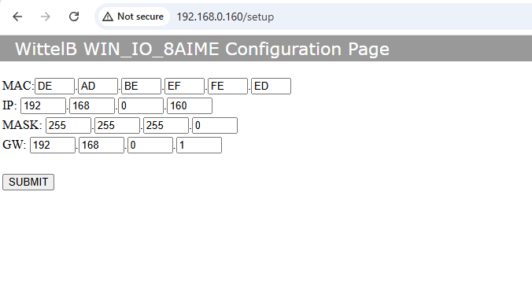
4DDAME

DI

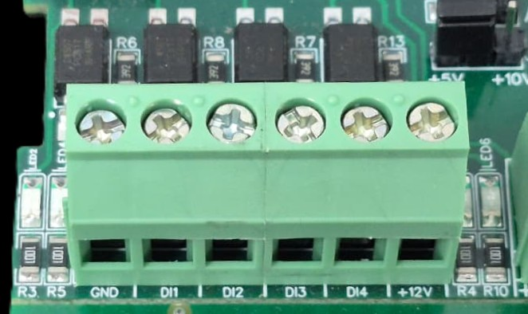
I/p device
I/p device
I/p device
I/p device

- Operation: The module provides four isolated input channels (DI1–DI4) for sensing external signals or dry contacts. These inputs are opto-isolated for circuit protection.
- Terminal Layout:
  - GND: Common Ground reference.
  - DI1 – DI4: Individual Digital Input channels.
  - +12V: Internal reference voltage for sourcing "Dry Contact" switches.
- Wiring Options:
  - Dry Contact: Connect a switch between the +12V terminal and any DI pin.
  - External Voltage: Connect the external signal to a DI pin and the external ground to the GND terminal.
- Voltage Rating: The input circuitry is rated for a maximum of 80VDC. Ensure external signals do not exceed this limit to prevent damage to the isolation ICs.

DO

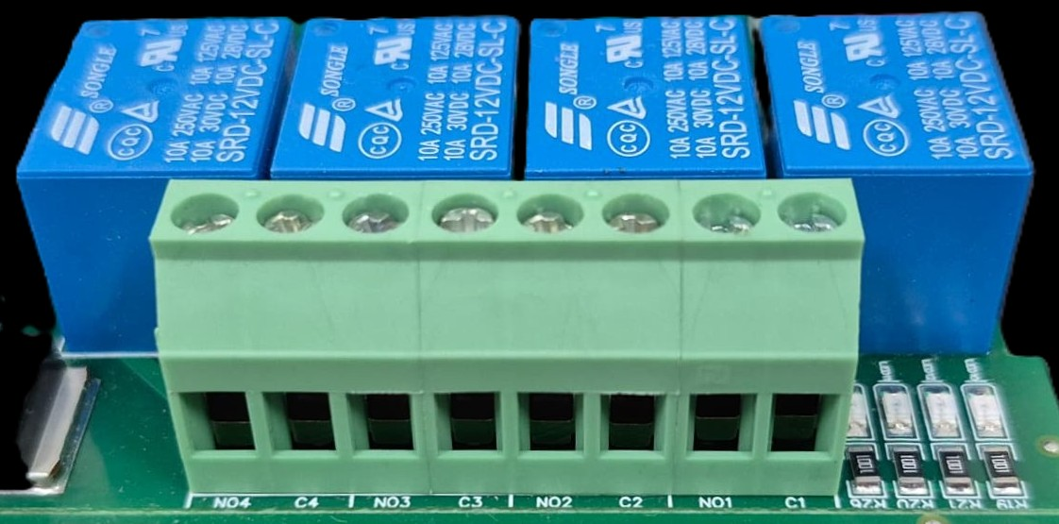




L
O
A
D
N

P
L
O
A
D
N

P
L
O
A
D
N

P
L
O
A
D
N

P

- Digital Output (DO) operation: Each channel provides two terminals: C (Common) and NO (Normally Open). When the relay coil is energized, terminal C is internally connected to NO, allowing current to flow. When the relay is de-energized, the connection between C and NO remains open, and the load stays OFF.
- Load Wiring Connections:
  - AC Load Connection: The AC Live (Phase) wire should be connected to terminal C. The load is connected between terminal NO and Neutral (N).
  - DC Load Connection: The positive supply (+V) should be connected to terminal C. The load is connected between terminal NO and Ground (GND).
- Crucial Safety Recommendation and Rating: It is strongly recommended to switch the Live (Phase) conductor in AC applications to ensure the load is safely de-energized when the relay is off.
Note: Ensure that the connected load does not exceed the relay’s contact rating of 10A @ 250VAC (or 10A @ 125VAC) or 10A @ 30VDC (or 10A @ 28VDC).

AI

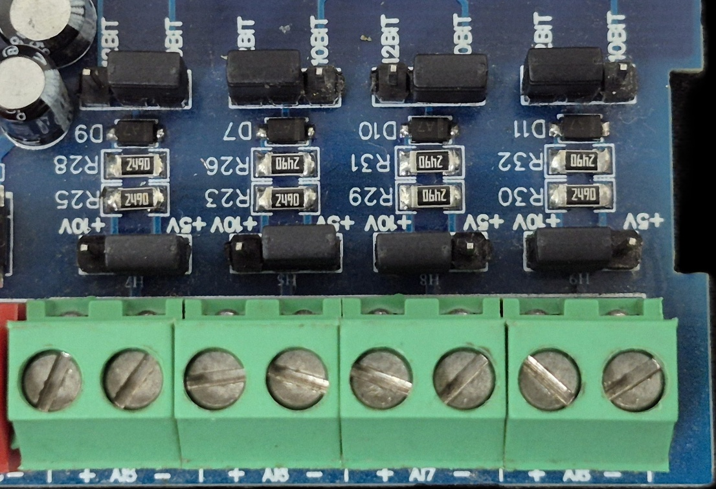
Sensor
Sensor
Sensor
Sensor

- Analog Input (AI) Operation: Each channel provides two terminals: + (Positive) and - (Negative/Common). These are used to read external analog sensor signals.
- Channel Configuration (Visual Guide): Each of the four AI channels features two dedicated jumpers to independently set the voltage range and bit resolution. Refer to the color-coded boxes in the board diagram to configure your desired scenario:
  - Red Box (5V, 10-bit): Set the voltage jumper to +5V and the resolution jumper to 10 BIT.
  - Green Box (5V, 12-bit): Set the voltage jumper to +5V and the resolution jumper to 12 BIT.
  - Blue Box (10V, 10-bit): Set the voltage jumper to +10V and the resolution jumper to 10 BIT.
  - Yellow Box (10V, 12-bit): Set the voltage jumper to +10V and the resolution jumper to 12 BIT.
- Sensor Wiring Connections:
  - The analog sensor's positive signal wire should be connected to the + terminal of the desired channel.
  - The sensor's common or ground wire should be connected to the corresponding - terminal.
- Crucial Setup Recommendation: Always ensure that the voltage jumper setting strictly matches the maximum output range of your connected sensor (either 5V or 10V) to guarantee accurate analog-to-digital conversion and prevent data clipping.
Product Image:

DO Ports
1 2 3 4

GD 4 3 2 1 +12V
DI +ve Pins
AI I/P
AI1 AI2

Input 24 VDC
5V / 10 V
AI Jumper
10 / 12 Bit
AI Jumper

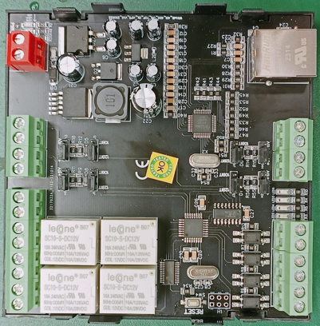
Modbus TCP Ethernet
AI4 AI3
AI I/p

Note – Configuration Guide is separately provided for the configuration of the module.

For more details: http://www.youtube.com/@wittelb

Contact Information
Augmatic Technologies Pvt. Ltd.,
Plot no 6, Shah Industrial Estate II,
Kotambi,
Vadodara – 391510.
Email – Sales@wittelb.com
Support: support@wittelb.raiseaticket.com / +91 94038 92805

